
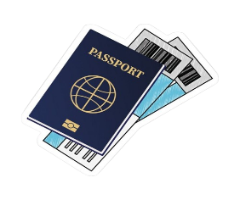


j
Holiday Check List
- Perfume
- Skincare
- Hair brush
- Shampoo
- Conditioner
- Gums
- Snacks
- Water bottle
Food
Toiletries
- iPad
- Phone
- Camera
- Chargers
- Note pad

Electronics
- Passport
- ID
- Money & Credit card
- Travel docs
- Keys
Accessories
Important
- Sunglasses
- Hats
- Bracelet
- Purse
- Waist chains
- Earring
- Necklace
- Jacket
- Skirt
- Dress
- Shoes
- Long top
- Trousers
- Tank
- Hoodies

CLOTHES

